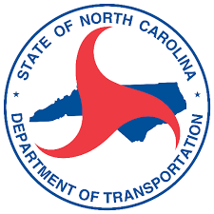

Anson County
Comprehensive Transportation Plan
April 11, 2022
Meeting Minutes

- Introductions
- What is a CTP? Presentation
Dominique presented the Anson County Comprehensive Transportation (CTP) Overview.
- CTP Steering Committee
  - Final Committee Member List
  - Handbook – Dominique presented the Handbook and discussed Roles and Responsibilities of Steering Committee members
  - Roles and Responsibilities
- Base and Future Year Discussion
Roger shared that this study’s base year will be 2019 due to available data and that 2020 was an irregular year due to Covid-19. The future year will be 2050.
- Anson County Travel Demand Model Presentation
Amar presented the Introduction to Travel Demand Modeling
- Public Involvement Introduction
Roger presented the Community Vision, Goals, and Objectives. G&O survey. Committee help to distribute, get feedback from as many people as possible.
  - How it will be carried out?
  - What is your role?
- Identification of Studied Roads
Roger presented a more robust Anson County network than previously studied, based on feedback from Amar (in TDM)
- Future Meetings
Lee discussed meeting monthly and all the work that will be involved. Dominique discussed CTP Schedule. Meetings will be held on the second Monday’s of the month.
  - Meeting frequency
  - Scheduled dates/times
- Wrap Up
Committee To-Do List:
- Review Steering Committee membership (add/modify/remove)
- Review Network Roads provided on the Anson County CTP website

